**Continuous Integration:**

* When developers make changes to the code and push it to SCM tool, there will be an automation process which picks the code and perform compilation, execute test cases and perform static code analysis and creates package if everything is fine

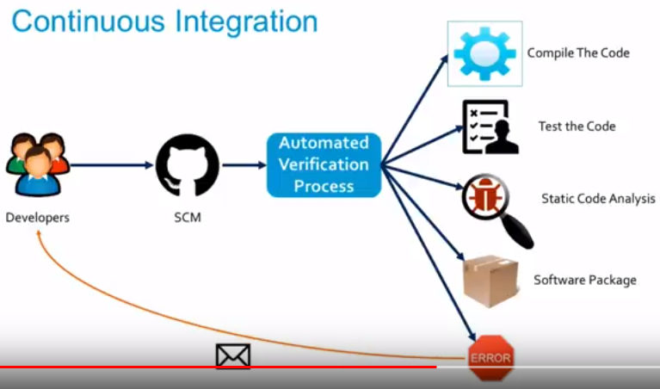

**Benefits:**

* It improves the developer’s productivity, because it is automated, when developers commit the code, it performs all the actions and give feedback to developers within minutes

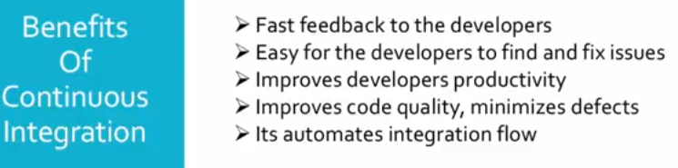

**Continuous delivery:**

* It is next step of CI, deploying the package into PROD servers

